Within your CentOS VM, do the following:

1. Basic File Administration
   1. Change directories to /opt/book/system-admin/ex2
   2. Rename hyde.txt to <your company’s name>.txt
   3. Make a copy of prince.txt named <your company’s name>.txt
   4. Make a directory called <your company’s name>_Security
   5. Copy the files gettysburg.txt and declaration.txt into your new directory and rename them <your company’s name>_audit1.txt and <your company’s name>_audit2.txt
   6. Display the first five lines of <your company’s name>_audit1.txt and the last five lines of <your company’s name>_audit2.txt
2. Basic User Administration
   1. Create three new users:
      * Name: Steve Jobs -- Username: jobs -- Password: Mac4ever
      * Name: Bill Gates – Username:  gates – Password:  dosLives84
      * Name: Linus Torvalds – Username: linus – Password:  ilovepenguins
   2. Create three new groups:
      * CEOs (members: jobs, gates)
      * unix_based (members: jobs, linus)
      * approved_OSs (members: jobs, gates, linus)
      * Make jobs the owner of <your company’s name>_audit1.txt
      * Make linus the owner of <your company’s name>_audit2.txt
   3. Change the group ownership of <your company’s name>_audit1.txt to the unix_based group and make it writable by that group. It should also be readable by all users
3. Install the “xorg-x11-apps” package, a collection of common GUI tools
   1. Run the command “xclock”
   2. Open a new terminal window and run the command “yum list xorg-x11-apps”
4. Update all the RPM packages currently installed on the system

IN A MS WORD DOCUMENT, SUBMIT THE FOLLOWING:

1. A screenshot of the contents of /opt/book/system-admin/ex2 and the file display output (10 points)

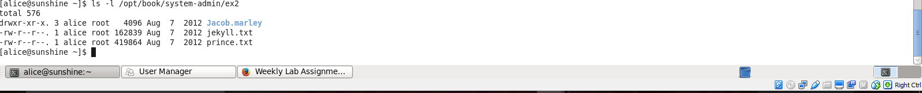

1. A screenshot of the owner/group file permissions for <your company’s name>_audit1.txt and <your company’s name>_audit2.txt (10 points)

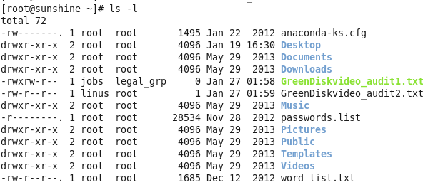  
  
  
  
3. A screenshot of the terminal and xclock windows (10 points)

  
  
  
  
4. A screenshot of the first line from /etc/issue (20 points)

